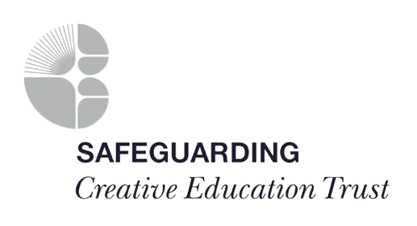
SGF5 – Signs of Safety Consideration tool

Academy Site
Name of Child |  | Year Group

What are we Worried About? | What is Working Well? | What Needs to Happen?

Safety Scale: Given the danger and safety information, rate the situation on a scale of 0-10, where 0 means recurrence of similar or worse abuse / neglect is certain and 10 means that there is sufficient safety for the child to take no further action.
ContextScale: Rate this case on a scale of 0-10, where 10 means this is not a situation where any action would be taken and 0 means this is the worst case of child abuse / neglect that the Academy has seen.

Date of Concern |  | Date of Consideration
Professional Completing |  | Professional Supporting
Signed |  | Signed
Who is responsible for uploading this onto CPOMS?

Notes

